 Wisconsin Green Industry Federation

June 4, 2007

The Honorable Representative Garey Bies
State Capitol
Room 125 W
P.O. Box 8952
Madison, WI 53708

Re: LRB 1926/1, SB-197: Restrictions on the use and sale of fertilizer containing phosphorus and other lawn fertilizer.

Thank you for meeting with us on May 9. We appreciate you inviting us to provide comments on your proposed bill. We are happy to work with you to create a bill that will have the desired effect and will have support of the consumers, retailers, fertilizer manufacturers and distributors, landscape professionals, lake and watershed organizations, and others. We offer the following suggested amendments germane to the bill, which will create statewide consistency and improve the existing ability of the WDATCP in the regulation of fertilizer:

Amendment #1

In 1993 Wisconsin passed the Pesticide Preemption Law due to a patchwork of ordinances around the state that were creating not only an enforcement nightmare, but also created a problem with landowners/farmers whose property crossed more than one county, town or village that might have all had different restrictions. The law has been working very well without any adverse impact to Wisconsin’s natural resources or to the health and safety of its citizens. Our groundwater protection law, and now the nonpoint source pollution law have provided for a comprehensive approach that is regulated by the DNR and DATCP at the state level.

Amendment # will accomplish the same goal; to ensure that fertilizer regulations in the state are science based and consistent. There are local ordinances that have recently passed in Wisconsin that not only create a patchwork approach for fertilizers, but may attempt to regulate weed and feed products that are registered and regulated as pesticides. This clear violation of the Pesticide Preemption Law further demonstrates the need to implement fertilizer preemption to clarify this issue.

Local fertilizer and use restrictions are unnecessary and burdensome to commerce
and to the strength of Wisconsin’s agricultural industry. We strongly believe that the
Department of Agriculture, Trade and Consumer Protection should have the authority of
how fertilizers are regulated.
This amendment generally prohibits political subdivisions from regulating fertilizers. The bill allows a political subdivision to regulate fertilizer use on property it owns; zone areas with respect to fertilizer manufacturing, distribution, and disposal; and
implement any regulation of fertilizers that the political subdivision is required by federal law or state law to implement. SECTION 2. 94.643 of the statutes is created to read:

94.643 Fertilizer; local regulation. (1) This section is an enactment of
statewide concern for the purpose of providing uniform regulation of fertilizers.
2) In this section:
a) “Fertilizer” has the meaning given in s. 94.64 (1) (e).
b) “Political subdivision” means a city, village, town, or county.
3) (a) Except as provided in par. (b), a political subdivision may not prohibit the use of or otherwise regulate fertilizers.
(b) A political subdivision may enact an ordinance that does any of the
following:
1. Regulates fertilizer use on property in which the political subdivision has a fee simple ownership interest.
2. Zones areas with respect to fertilizer manufacturing, distribution, and disposal.
3. Implements any regulation of fertilizers that the political subdivision is required by federal law or state law to implement.
(4) (a) No later than the first day of the 3rd month beginning after the effective date of this paragraph .... [revisor inserts date], a political subdivision shall provide the department with a copy of any ordinance that is authorized under sub. (3) and that is enacted before the effective date of this paragraph .... [revisor inserts date].
(b) A political subdivision may not enact an ordinance that is authorized under sub. (3) until it consults with the department. If a political subdivision enacts an ordinance that is authorized under sub. (3), it shall provide the department with a copy of the ordinance no later than 60 days after enactment.

Amendment #2

Option 1: Delete (4) Restriction on Display. Some products labeled for use on lawns, also may be labeled for use on trees, shrubs, flowers, vegetable gardens, etc. This restriction would present problems for manufacturers who register, label, package, and distribute products labeled for multiple sites, which is very common. This would cause manufactures financial hardship, and retailers with limited products to offer customers, let alone display.

Current language holds retailers in violation if they display lawn fertilizers containing phosphorus, although it is legal for a merchant to sell the product to any customer upon request. A large part of marketing products to the public is having the product on display, and this would severely limit the ability to market a perfectly legal product. In addition many stores have very limited amounts of storage area for pallets of lawn fertilizer which is out of the customer’s sight, or could be readily accessible to the merchant or clerk to obtain for the customer. This also puts the retailer in the position of being a violator subject to the penalties noted.

Option 2: Amend as follows: (4) RESTRICTION ON DISPLAY. No person who sells fertilizer at retail may display lawn fertilizer that is labeled as containing phosphorus. A person who sells fertilizer at retail may must post a sign advising customers that lawn fertilizer containing phosphorus is available upon request for uses permitted by sub. (2) (b).

Merchants in Wisconsin are already required to have lawn signs and pesticide information sheets available free of charge to retail consumers at the point of sale of pesticide products. ATCP 29.41(3) (a) Wis. Admin Code. Posting of this additional sign at the point of sale of phosphorus-containing lawn fertilizers would insure that the public is notified of the restrictions on the use of phosphorus-containing fertilizers.

Thank you for allowing us to provide comments on your proposed bill. We hope we can work with you in this endeavor.

Sincerely,

The Wisconsin Green Industry Federation
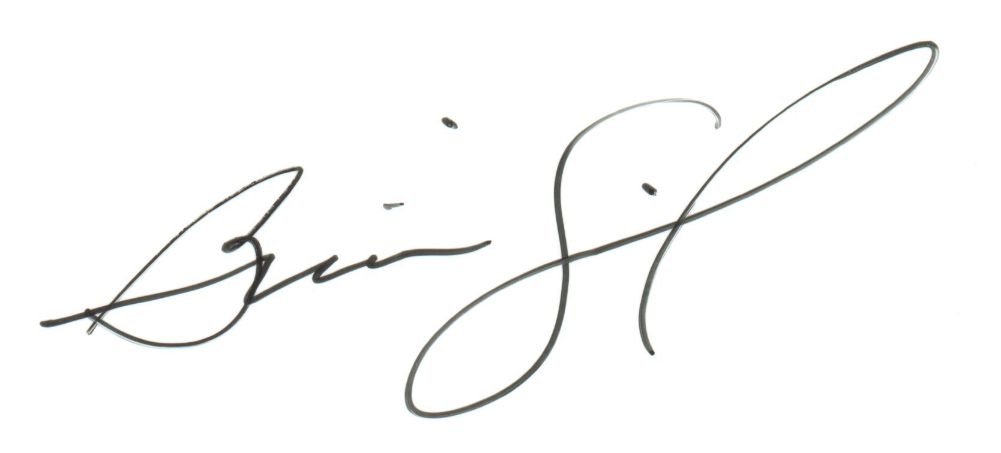
Brian Swingle
Executive director

Cc: Representative Mark Honadel
Senator Mark Miller

